SECTION 1: Hands-On Demonstration

Part 1. View Existing ACLs on a Windows System

1. original permissions for the Shopfloor group in the SFfiles directory (screen capture):

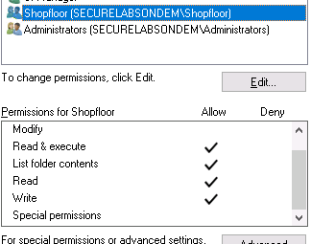

1. original permissions for the HumanResources group in the HRfiles directory (screen capture):

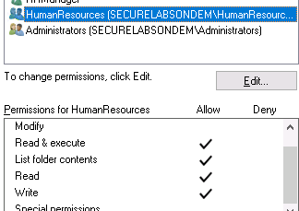

original permissions for the Managers group in the MGRfiles directory (screen capture):  
  
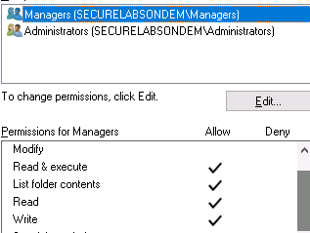

Part 2. Modify ACLs using Icacls.exe

1. compare the results of the icacls.exe command with the ACLs you documented in Part 1 of this lab: (screen capture accepted)



1. compare the results of the icacls.exe command after modifying the ACLs: (screen capture accepted)



1. icacls.exe results for updated SFfiles directory permissions (screen capture)

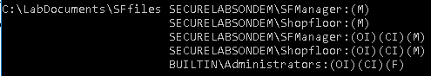

1. icacls.exe results for updated HRfiles directory permissions (screen capture):



1. icacls.exe results for updated MGRfiles directory permissions (screen capture):



Part 3. Validate ACL Settings

1. modified New Text Document in the SFfiles directory (screen capture):

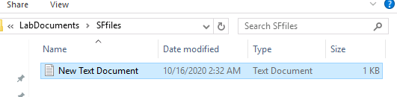

1. modified New Text Document in the HRfiles directory (screen capture):

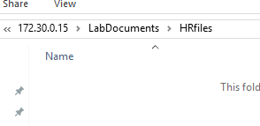

1. modified New Text Document in the MGRfiles directory (screen capture):

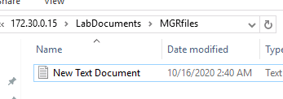  
  
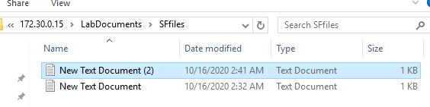

SECTION 2: Applied Learning

Part 1. Modify a Script to Add a New User

1. the new user account in Part 1 of the script (screen capture):

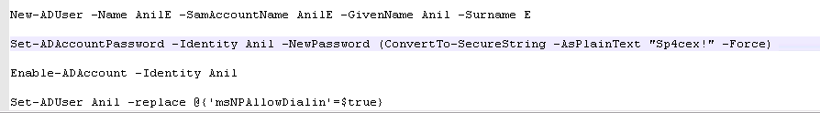

Part 2. Modify a Script to Add a New Group

1. modifications to Part 2 of the script (screen capture):

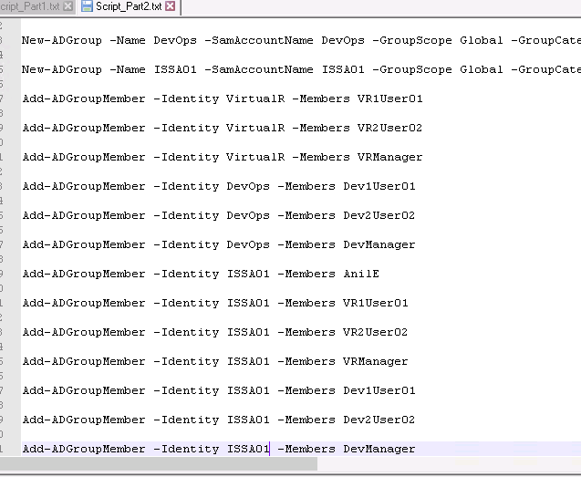

Part 3. Modify Permissions Using a Script

1. current contents of the TargetWindows01 C: drive (screen capture):

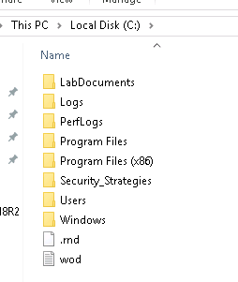

Part 4. Create Directories Using a Script

1. modifications to Part 4 of the script (screen capture):



1. contents of the new LabDocuments2 directory (screen capture):

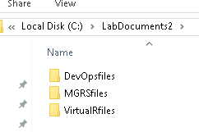

1. the permissions for the ISSA01 security group (screen capture):

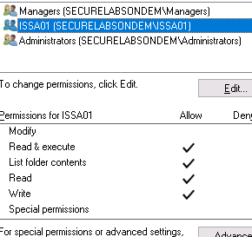

1. members of the ISSA01 security group (screen capture):  
     
   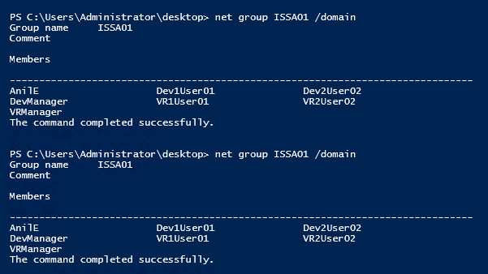

SECTION 3: Observation Summary

In section one, we looked at original permissions for the Sffiles, HRfiles, MGRfiles directories. Then we used icacls command to add permissions to some users and user groups for some folders. Then we logged in as these users and checked whether the changes we made worked.

In section two, we worked on a four part script that creates users, groups, and directories. Then we merged these scripts and executed it from powershell and checked whether it actually created the users and user groups with the right permissions for the right folders.